Week 3 Deliverables
Deliverable #1 (Nathan Aird + Cody Ferguson)

- Chef – show me the salary of each chef listed in the table. Ensure this salary is displayed correctly as the Irish pound. Do NOT hardcode the euro dollar sign.
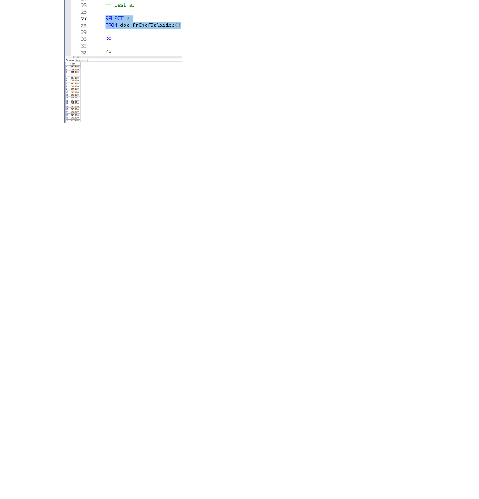
- Show me the kitchen details by kitchen.
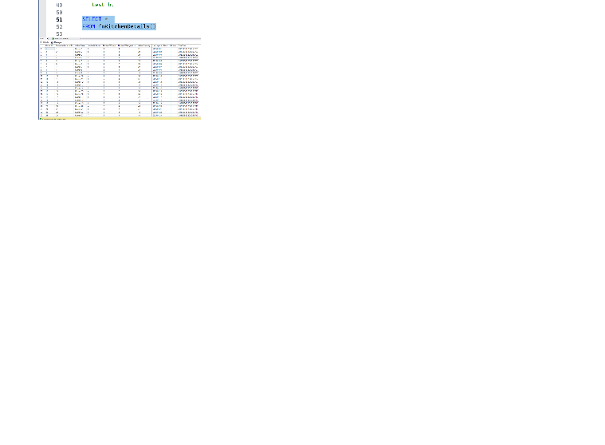
- Menu price – show me the unique menu items along with the price of those dishes.
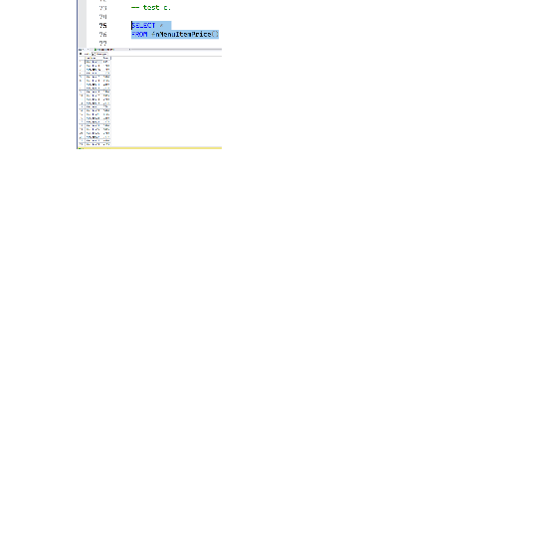
- Show me the distribution of how orders are placed (in-person, online, phone). Show this as a sum of each, with an overall sum for all options.
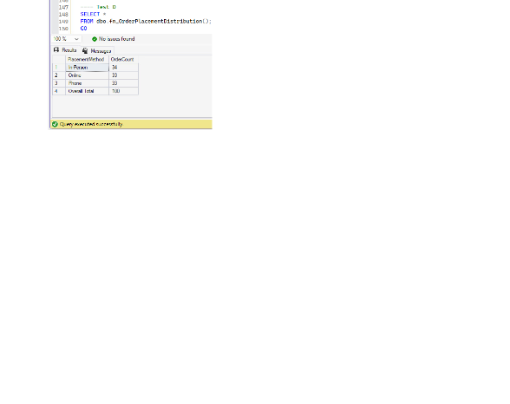
- Show me the reservations and how many patrons receive their favorite table and those that don’t.

